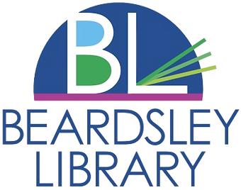

Dear Parents/Guardians,

We are excited to announce an upcoming program on Friday, July 26th from 2:30-4:00 pm organized by Beardsley Library. Taking place at the Winsted Rail Trail and Railway Cafe in Winsted, this Geocaching Adventure will offer an engaging and educational experience for your teen! Please see the attached permission slip that must be signed and returned to Miss. Emily by July 24th.

Details of the program are as follows:

* Location: We will MEET at the library, then all walk over to the Winsted Rail Trail. Following our discovery of geocaches, we will walk down to the Railway Cafe to get an ice cream, then return back to the library.
* Date: July 26th, 2024
* Time: 2:30-4:30 pm
* Meeting Point: Beardsley Library

During the program, the teens will be under the supervision of teen librarian Emily Young, as well as Kimmie Killmer, director of Beardsley Library. We will be engaging in Geocaching activities using the Geocache app, exploring the trail, and discovering hidden Geocaches along the way.

To ensure the safety of all participants, we kindly request that your teens adhere to the following guidelines:

1. **Dress Appropriately:** Please ensure your teen dresses appropriately for the event depending on the weather and wear suitable walking shoes.
2. **Navigational Capability:** Participants should be capable of navigating the trail for approximately one to one and a half hours. Please ensure appropriate attire and equipment for mobility needs.
3. **Bring Essentials:** We recommend your teen bring a small bag or backpack containing plenty of water, sunscreen, or anything else needed over the course of an hour and a half.

***Liability Statement:*** While every effort will be made to ensure the safety and well-being of all participants during the Geocaching program, Beardsley Library and its representatives cannot be held responsible for any accidents, injuries, or losses that may occur. By signing this permission slip, parents/guardians agree to release Beardsley Library, its staff, and volunteers from any liability arising from participation in the program.

By signing this permission slip, you agree to allow your teen to participate in the Geocaching program and acknowledge the details outlined above. Please complete the bottom portion of this letter and return it to Emily Young at Beardsley Library by July 24th. If you have any questions or concerns, please do not hesitate to contact us at 860-379-6043.

We thank you for your cooperation!

Sincerely,

**Emily Young**

Teen Librarian

Eyoung@beardsleylibrary.org

Beardsley Library, Winsted CT

**Permission Slip:**

I, [Parent/Guardian Name] give permission for [Teen Name] to participate in the Geocaching program organized by Emily Young at the Beardsley Library on July 26th at the Winsted Rail Trail and Railway Cafe in Winsted, CT. I understand and agree to the details provided in the letter above.

**Parent/Guardian Signature:** _______________________________

**Parent/Guardian Printed Name:** ___________________________

**Teen Signature:** _________________________________________

**Teen Printed Name:** ______________________________________

**Date:___________________________________________________**